**Electronics 2**

**Lab 2 report**

**MOS-FET Applications**

**Members:**

* Akibur Rahman
* Alexios Sidiropoulos

**Task 1: Amplifier**

Devise a MOS-FET-amplifier according to the shown circuit having an amplification factor of v = 30. Check the operating point you have calculated with. Measure the amplification factor using a frequency of f = 1kH.

figure 1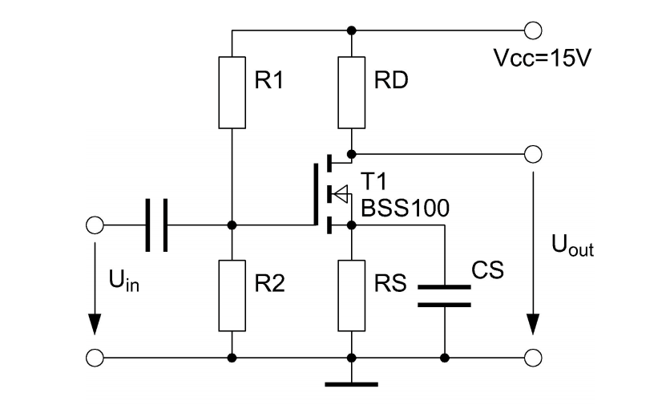

As instructed we used BSS108 transistor for our circuit, instead of the BSS100.

R1 = 150 kΩ

R2 = 47 kΩ

RD = 1 kΩ

RS = 2 kΩ

CS = 470 μF

Left capacitor C = 0.47 μF

Since we neglected channel length modulation, gain can be calculated by this formula :

Av=RDgm

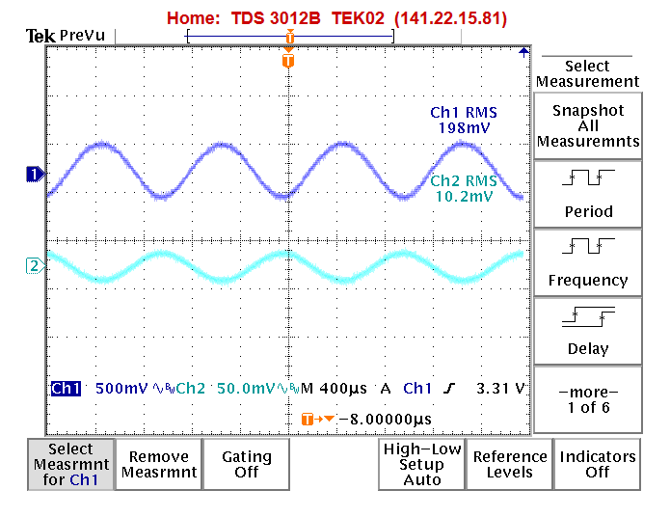

figure 2

Based on chosen components the amplification factor is almost 20 as is shown in oscilloscope screen shot :

198 mv/10.2 mv ≈ 20.

**Task 3: CMOS-Inverter**

Set up a CMOS-inverter according to the shown circuit. Draw the characteristics Uout = f (Uin) and I = f(Uin) with Uin ranging from zero to 5V by means of an XY-recorder.

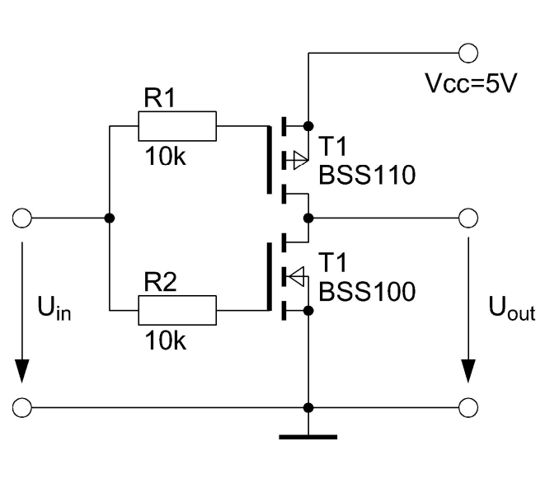

figure 3

On the following diagram we draw characteristics UOUT = f(Uin) and I = f(Uin) on the same paper as instructed by the lab assistants. Instead of using the BSS110 and BSS100 transistors we used the BSS250 and BSS108, respectively. To draw the characteristics of I = f(Uin) we needed to add an additional resistor of low resistance (R = 1 Ω) connected to the Source of the transistor BSS250 and then connected the wire linking the circuit to the Y-axis of the XY-plotter.

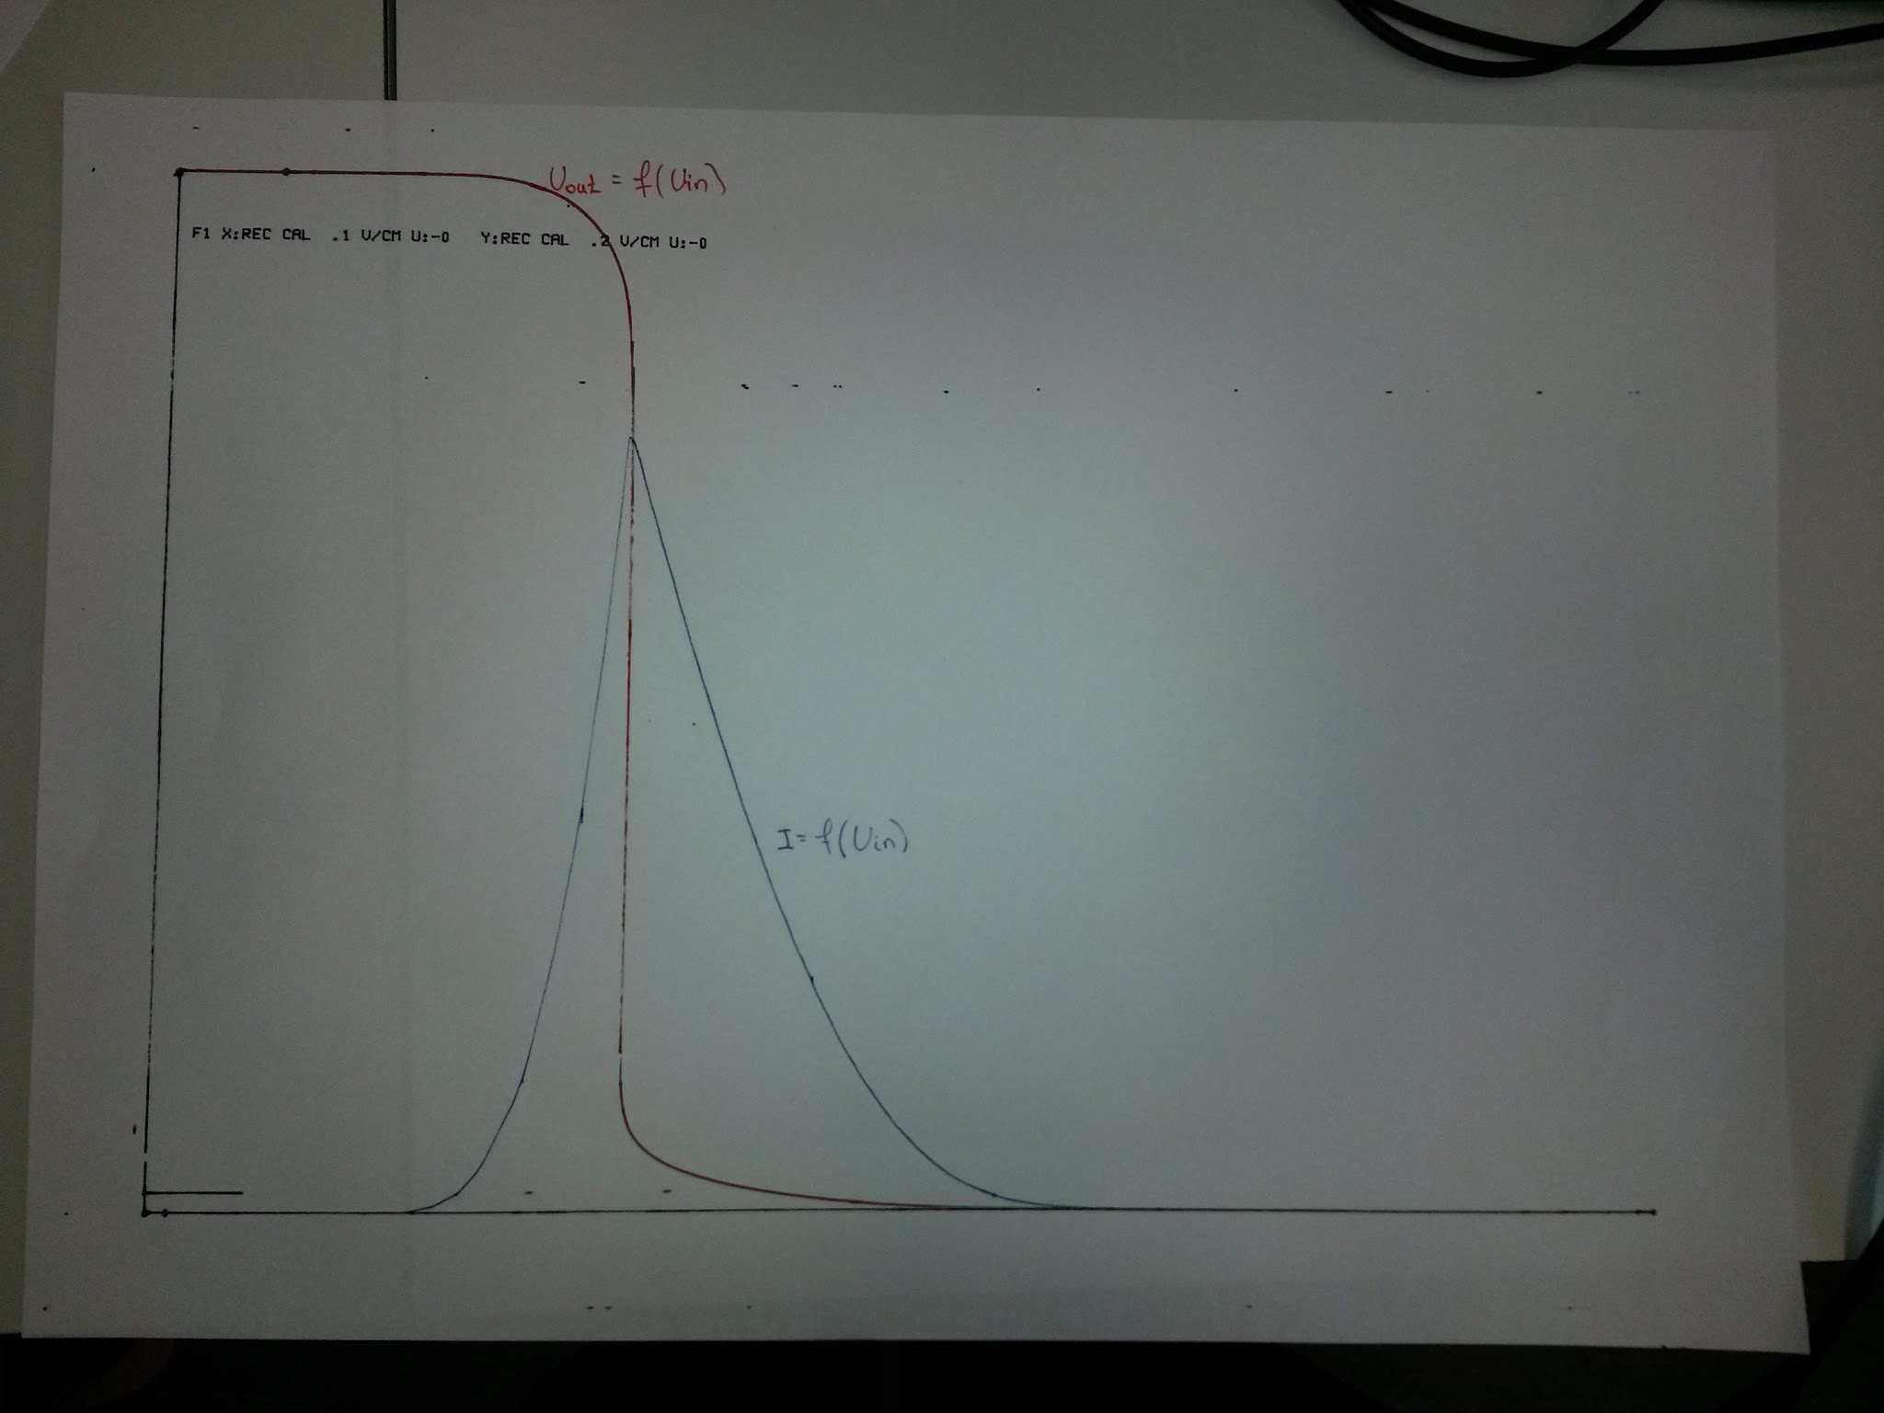

figure 4

By ranging the input voltage from zero to 5V, first for Uout = f(Uin) and after for I = f(Uin) we managed to get the plot above.

Since this circuit is a inverter, we should not have any gain, so absolute value of Uout should be the same as absolute value of Uin.

As can be seen, we only have current at the moment that the voltage is changing and after the change of voltage, current goes to zero again.